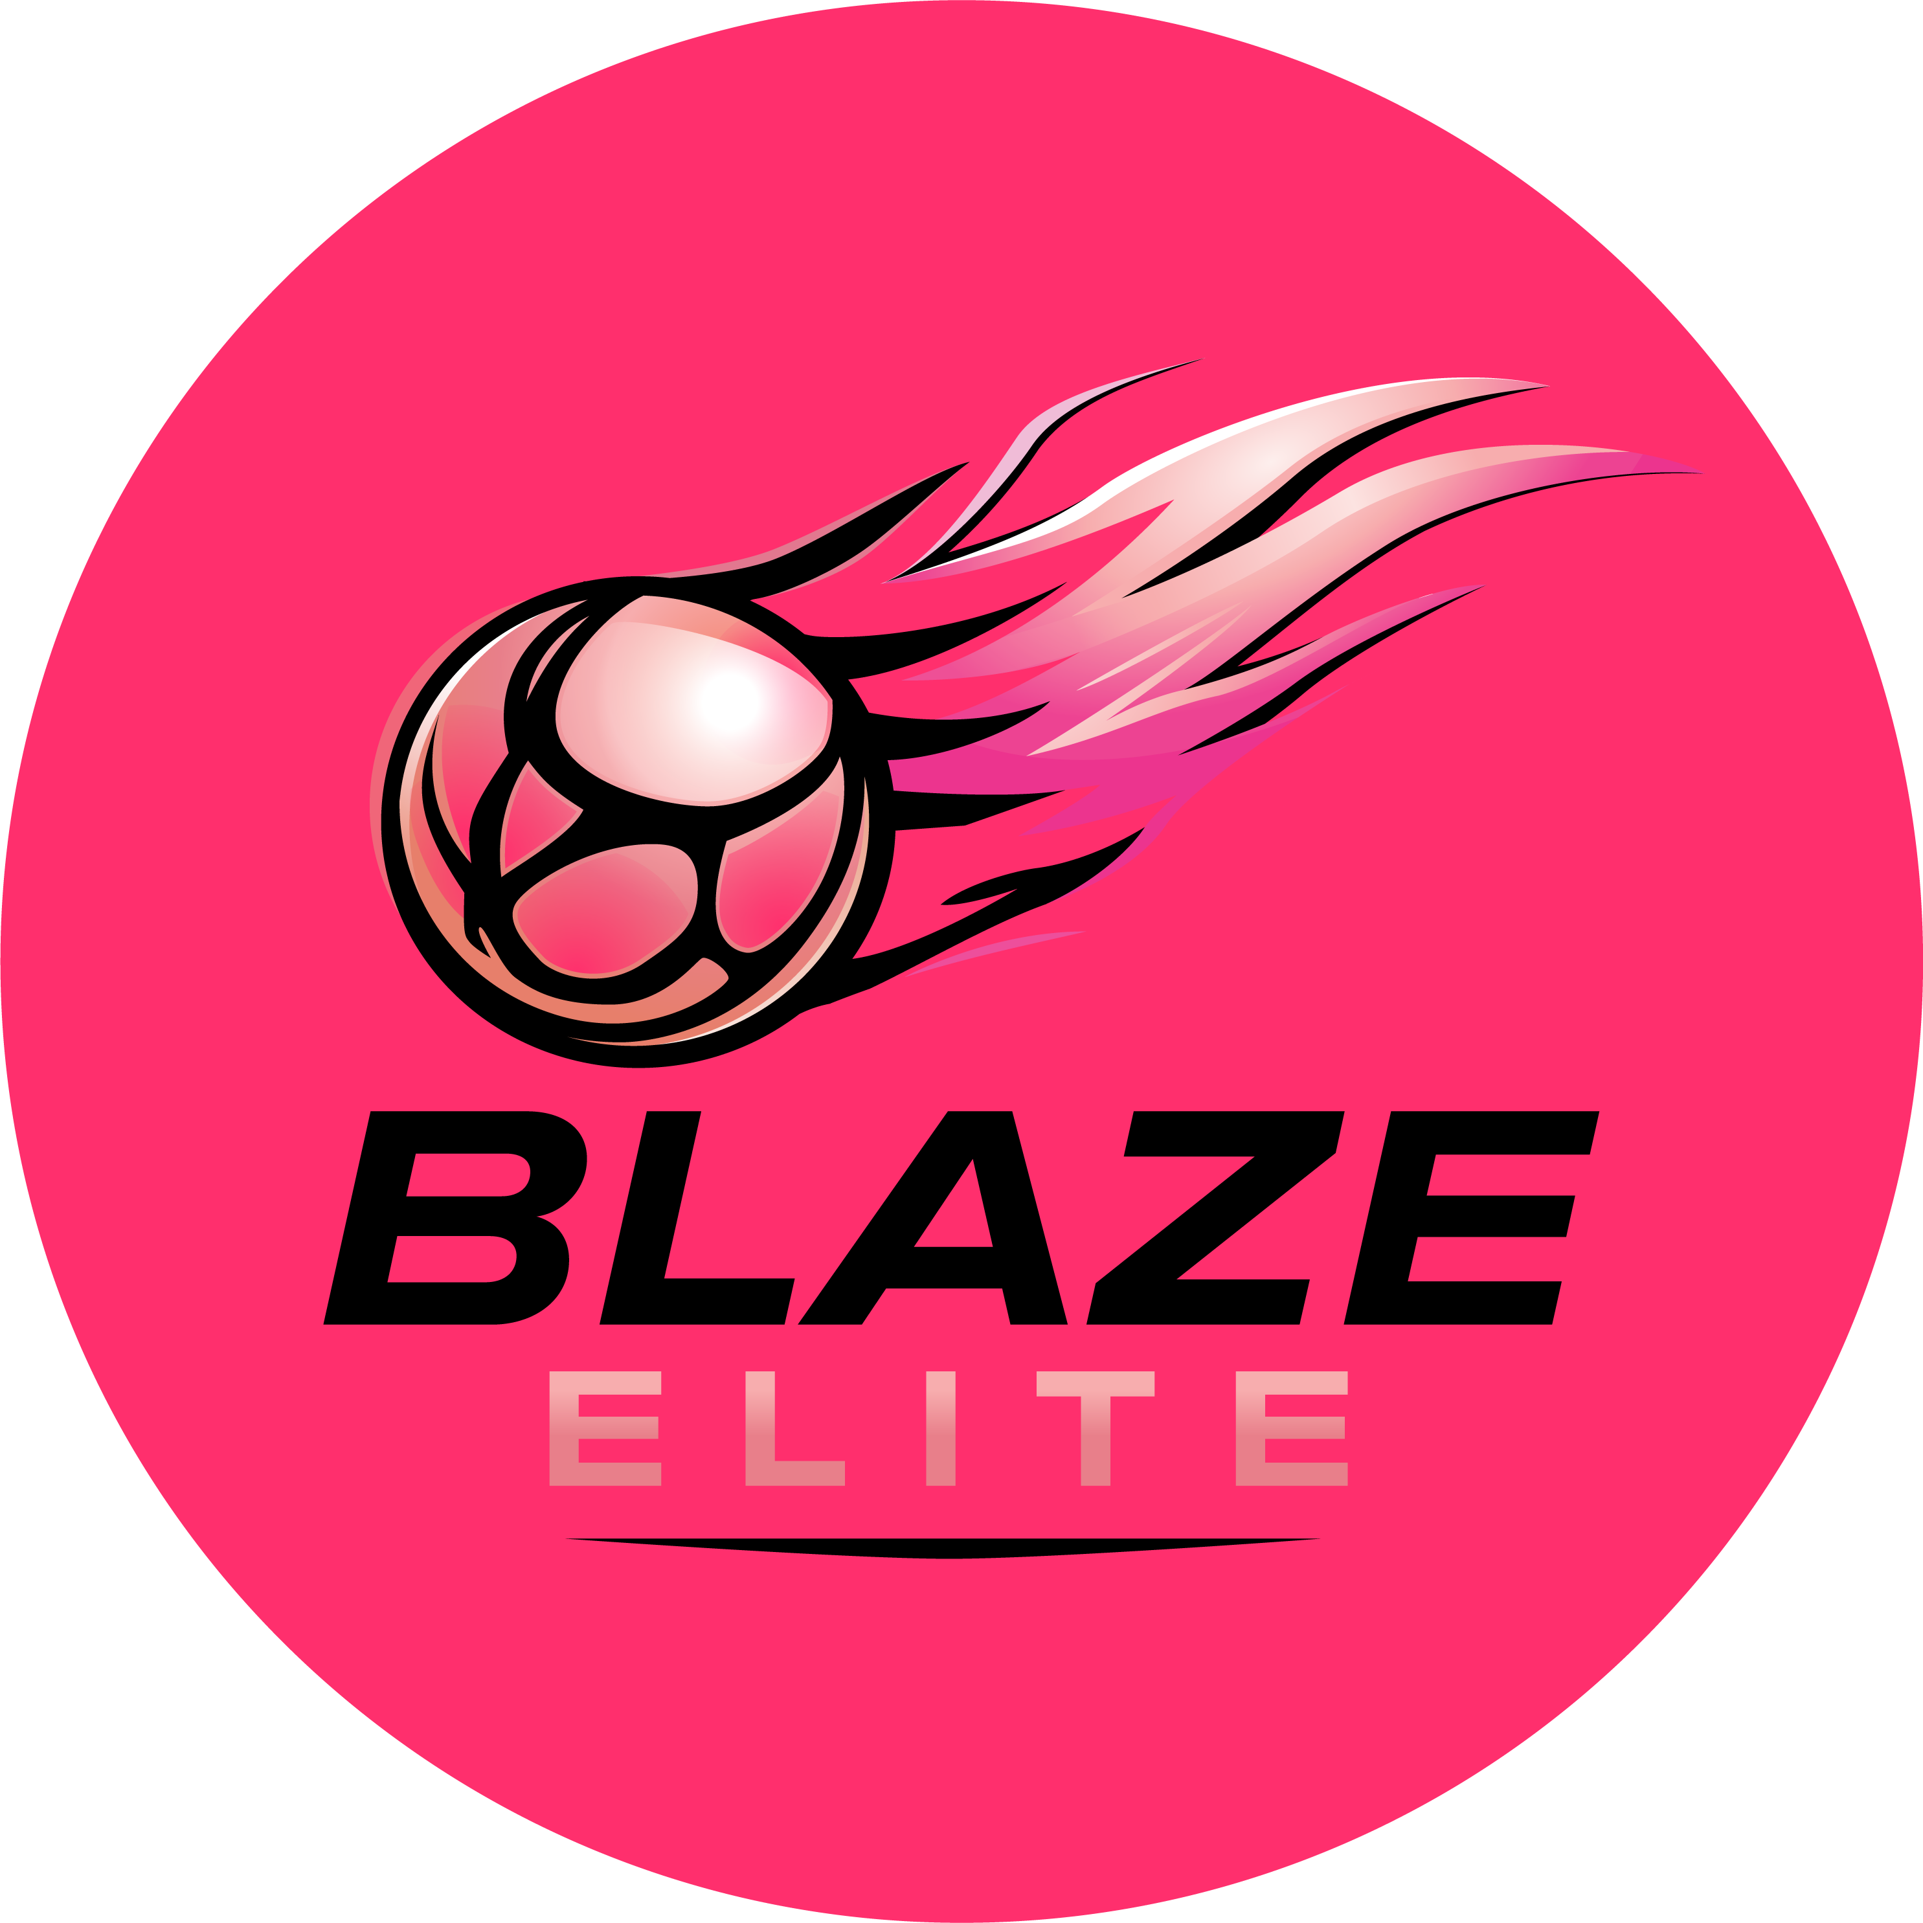

Trial Information
Blaze Elite Netball Club

1. Before You Trial
Blaze Elite is a high-performance club. Trials are competitive, and not every athlete who trials will be offered a place. It's worth thinking carefully about whether this environment is the right fit before applying — if you're unsure, feel free to contact us with any questions in advance.

2. What to Wear
- Plain kit only: a plain white top and black or navy shorts/skort — please do not wear kit branded with another club's logo.
- Hair tied back, nails trimmed, no jewellery.
- Bring warm outer layers (a hoody or tracksuit) to wear between matches.

3. What to Bring
- A bag to store your belongings — phones and other valuables are not permitted on court, and there are no locker facilities.
- Sufficient water and snacks.
- Any medication you may need (for example, an inhaler).

4. On the Day
- Arrive in good time before your scheduled start to allow for registration.
- Listen carefully to coaches and selectors — you may be asked to play in more than one position or match during the trial.
- Only athletes are permitted on the court during the trial.

5. After Your Trial
All athletes will be informed of the outcome of their trial within a few days. Due to the volume of athletes trialling, we are not able to provide individual feedback to unsuccessful athletes.

6. Questions
If you have any questions ahead of your trial, please get in touch via the contact details on the Blaze Elite website.

